Software Development Lab Documentation  
R Learning Notes

Senthil Ramasamy, 2013103602

( Teamed up with Sanjana 2013103601 for the project )

www.senthilr.com@gmail.com

horizontal line

# 12th July 2016

**Basic Installation**

Command to start R in the terminal without RStudio **R**

**install(“package_name”)**

**On the Command Prompt**

**myString <- “hellow world dude”**

**Print ( myString)**

**[1] “ hellow world dude”**

You can also run it as a script file,

**Rscript test.R**

Where in test.R creates the set of commands, and the output ll be displayed similar to shell

**Comments**

**#Comments**

**DataTypes**

**5 basic ones**

**1. Character**

**2. Numeric**

**3. Integer**

**4. Complex**

**5. Logical**

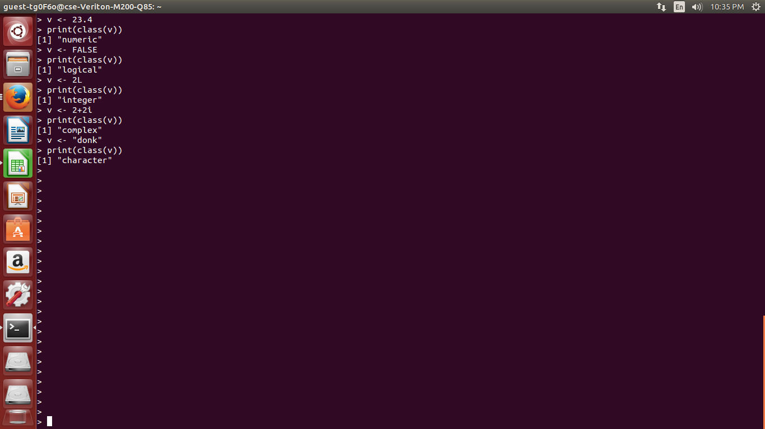

**Vectors and Lists**

**# Create a vector.  
 apple <- c('red','green',"yellow")  
 print(apple)  
  
 # Get the class of the vector.  
 print(class(apple))**

**#vector other method of creation**

**Vec <- c(argvalues,...,....,....)**

**#multiply element by element**

**Vec1 * vec2**

**#create dummy empty vecotrs of spec length**

**vector(“class_name”,number)**

**# concatenate function**

**c(args,...,...,...)**

**#explicit and implicit coercion**

**as.numeric(x)**

**Example**

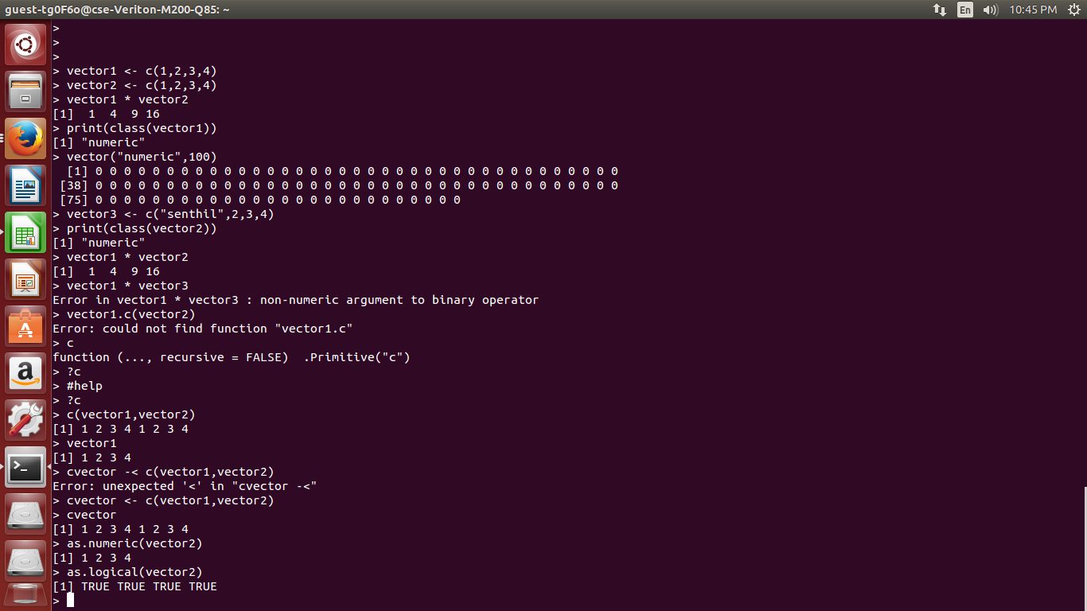

**Lists**

**# Create a list.  
 list1 <- list(c(2,5,3),21.3,sin)  
  
 # Print the list.  
 print(list1)**

**#paste function**

**paste (vec1,vec2, seperator)**

**#join the elements together with seperateor inbetn --- collapse parameter**

**Example \**

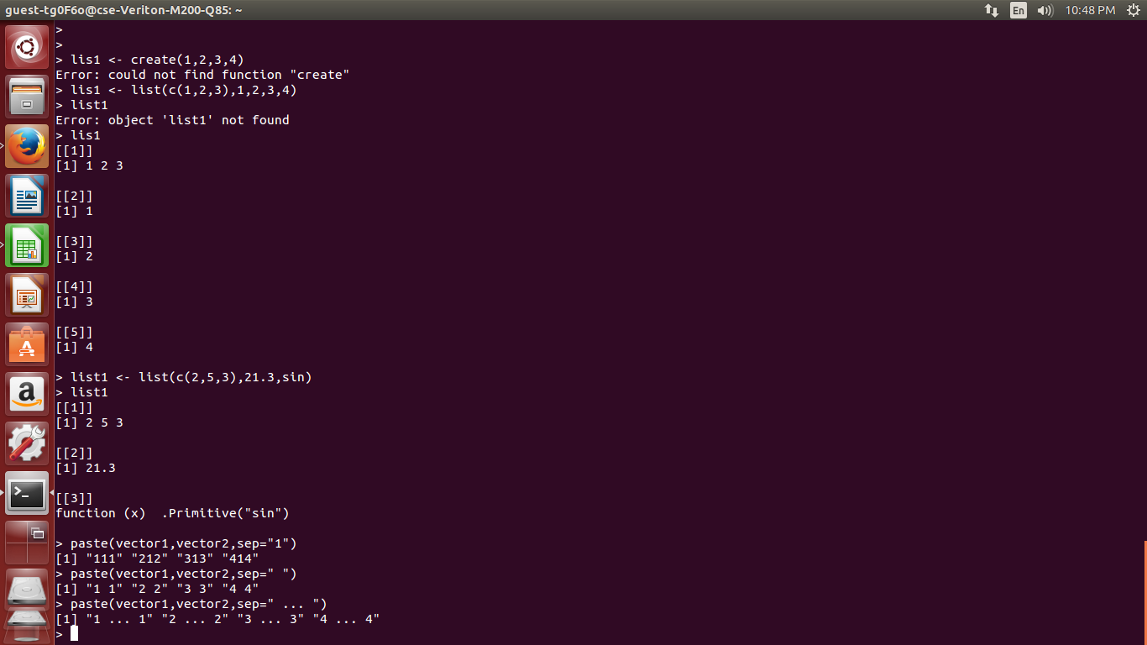

**Matrices, Arrays and Data Frames**

**# Create a matrix.  
 M = matrix( c('a','a','b','c','b','a'), nrow = 2, ncol = 3, byrow = TRUE)  
 print(M)**

**#can contain only 1 type of dataset**

**# Create the data frame.  
 BMI <- data.frame(  
 gender = c("Male", "Male","Female"),   
 height = c(152, 171.5, 165),   
 weight = c(81,93, 78),  
 Age = c(42,38,26)  
 )  
 print(BMI)**

**# Create an array.  
 a <- array(c('green','yellow'),dim = c(3,3,2))  
 print(a)**

**Differences**

**Matrix one data type only**

**Data.frame can contain multiple**

**Example**

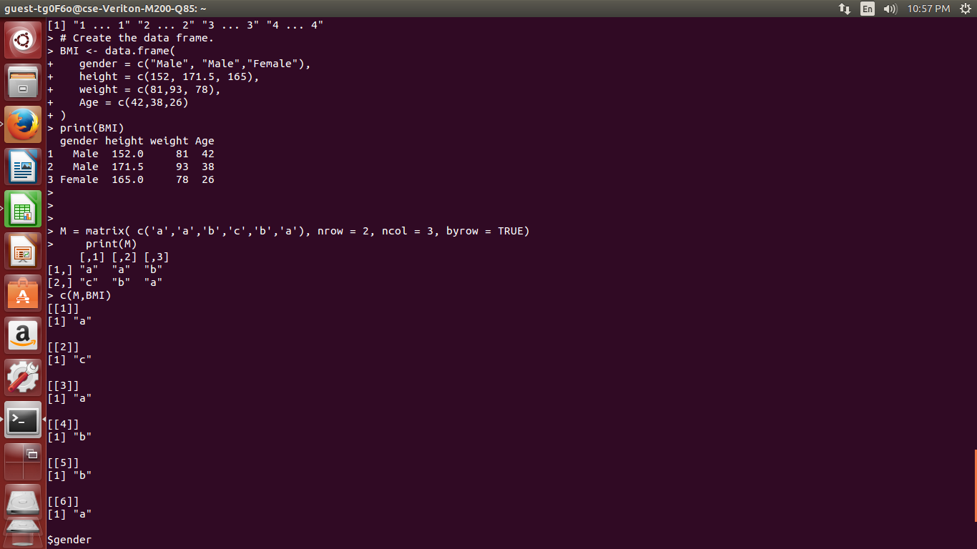

**Rbind and Dim**

#matrices can also be created by adding the dimension attribute to vector

**dim(m) <- c(2, 5)**

#matrices can also be created by binding columns and rows

**rbind(x, y)**

**cbind(x, y)**

# can be used on vectors or matrices

**Example**

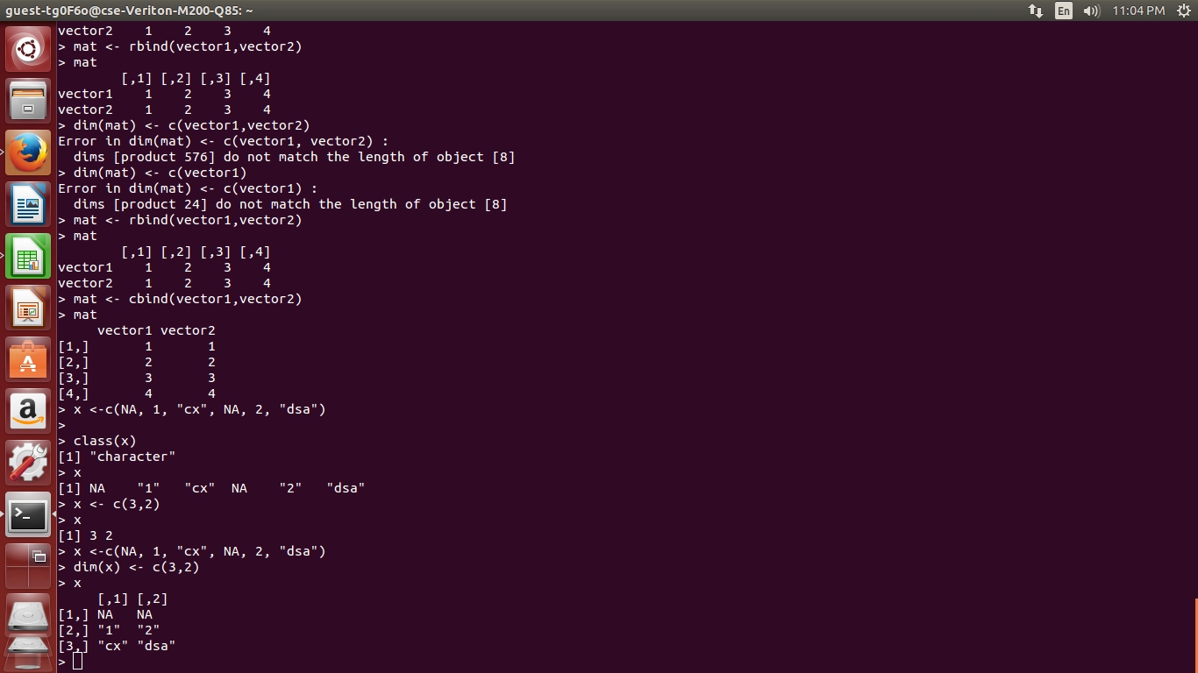

**Factors**

**#used to represent categorical data**

**factor(c(“a”,”b”),levels = c(“1”,”2”))**

**Other commands are**

**lm()**

**glm()**

**levels()**

**table(factorvar)**

**Arithmetic with R**

**# An addition**

**5 + 5**

**# A subtraction**

**5 - 5**

**# A multiplication**

**3 * 5**

**# A division**

**(5 + 5) / 2**

**# Exponentiation**

**2^5**

**# Modulo**

**28 %% 6**

**Example**

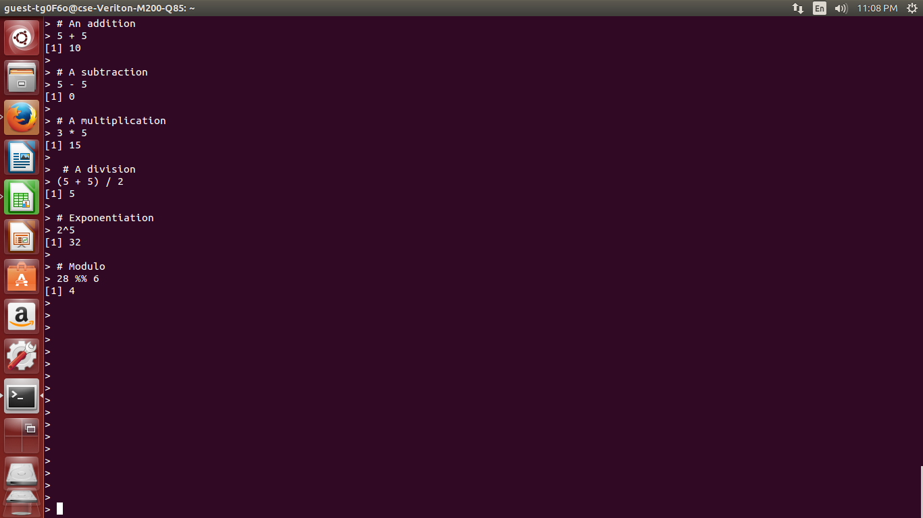

**Variable Assignments with R**

**# Assignment using equal operator.  
 var.1 = c(0,1,2,3)   
  
 # Assignment using leftward operator.  
 var.2 <- c("learn","R")   
  
 # Assignment using rightward operator.   
 c(TRUE,1) -> var.3**

**Special Operators**

**V <- 2:199**

**print(V)**

**%in%**

**#BELONGS IN THAT VECTOR SET ?**

**%*%**

**#MULTIPLY MATRIX WITH TRANSPOSE, ELSE IF YOU FOLLOW NORMAL MULTIPLACTION “NON CONFORMABLE ARRAYS”, COZ ROW N COL DIFFERS**

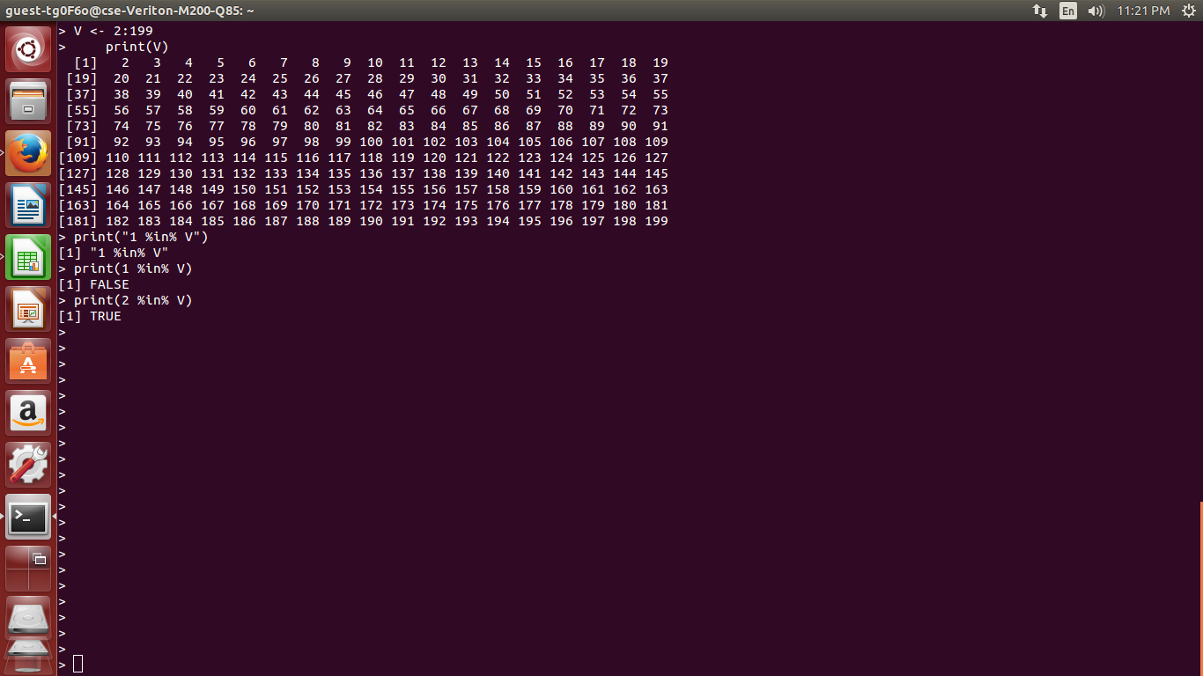

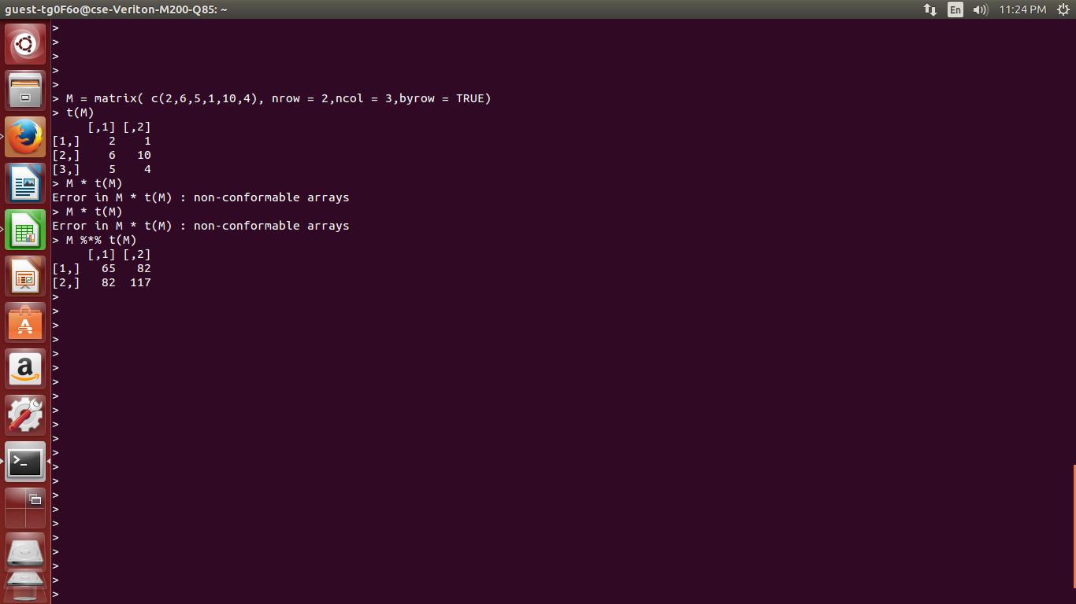

**Understanding Data**

**• use class(), dim(), nrow(), ncol(), names() to understand dataset**

**• head(data.frame, 10), tail(data.frame, 10) = returns first/last 10 rows of data; default = 6**

**summary()**

**# provides different output for each variable, depending on class,**

**– for numerical variables, displays min max, mean median, etx.**

**– for categorical (factor) variables, displays number of times each value occurs**

**table(data.frame$variable)**

**#table of all values of the variable, and how many observations there**

**str(data.frame)**

**# structure of data, provides data class, num of observations**

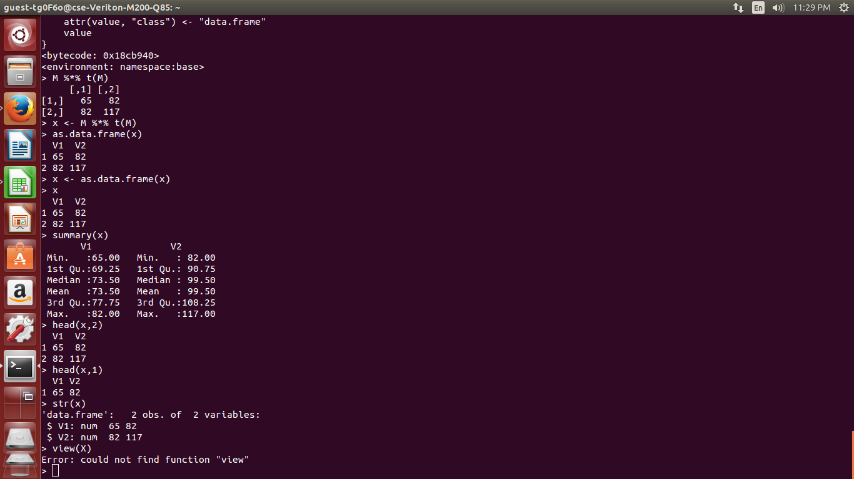

**Condition**

**x <- c("what","is","truth")**

**if("Truth" %in% x) {**

**print("Truth is found")**

**} else {**

**print("Truth is not found")**

**}**

**# above is if else loop**

**x <- switch(  
 3,  
 "first",  
 "second",  
 "third",  
 "fourth"  
 )  
 print(x)**

**#switch loops**

**Example**

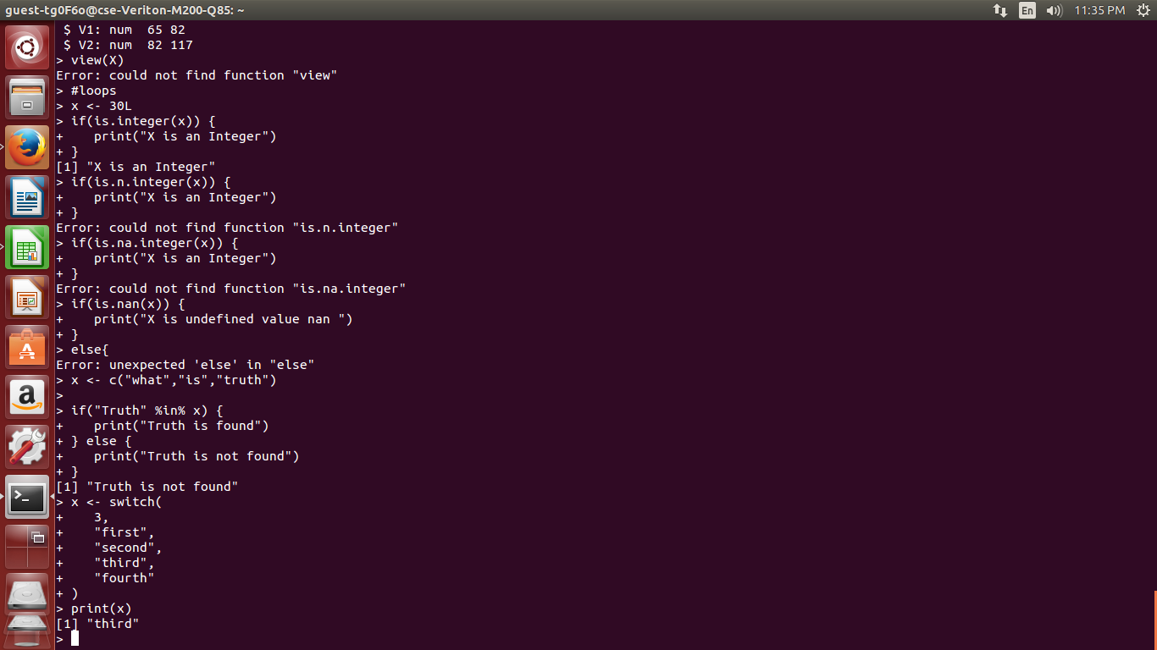

**Loops**

**#Repeat Loop**

**v <- c("Hello","loop")  
cnt <- 2  
  
repeat {  
 print(v)  
 cnt <- cnt+1  
   
 if(cnt > 5) {  
 break  
 }  
}**

**#while loop**

**v <- c("Hello","while loop")  
cnt <- 2  
  
while (cnt < 7) {  
 print(v)  
 cnt = cnt + 1  
}**

**#for loop**

**v <- LETTERS[1:4]  
for ( i in v) {  
 print(i)  
}**

**Example**

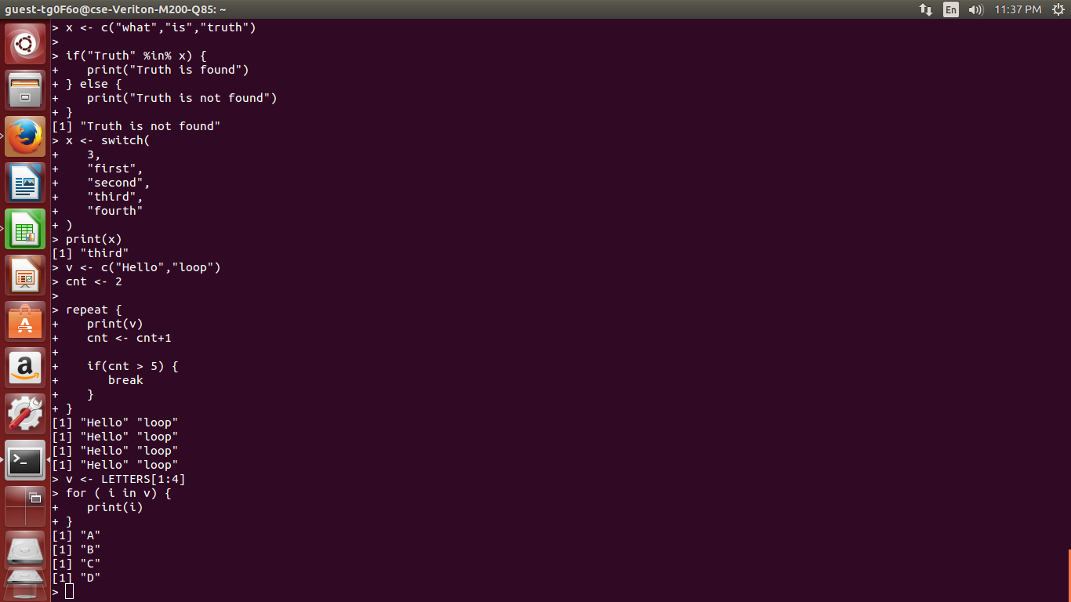

**Errors**

**----------**

While using %*%, i tried to multiply matrix and transpose of the same with *,

But error was “non conformable arrays”, so i resorted to using %*%, it worked

-----

In Vectors, i tried,

> v <- c("senthil",1,2,3)

> v

[1] "senthil" "1" "2" "3"

> class(v)

[1] "character"

> v * 12

Error in v * 12 : non-numeric argument to binary operator

This was because of the implicit one it was taking as “senthil” as character.

--------

In dimension, dim there was object [8] not suitable type or length errors,

It was because i was using dim with a non conforming one. Later created a new one suitable for my dim then it worked

-----

Package installation error, rectified using stackoverlow docs

---

Otherwise syntax errors and spell errors

**Task Points ( Next Week )**

* **Decide upon the project**
* **Submit abstract**
* **Download and look for dataset**
* **Understand the same and clean it**
* **Set the environments and things specific to my project**
* **Diagrammatic flow of what is to be done**